Jawwad Sarwar
JAWWAD SARWAR EL-22095
verilog TASKS UPDATE
WEEK 2

REG32:

WAVEFORM
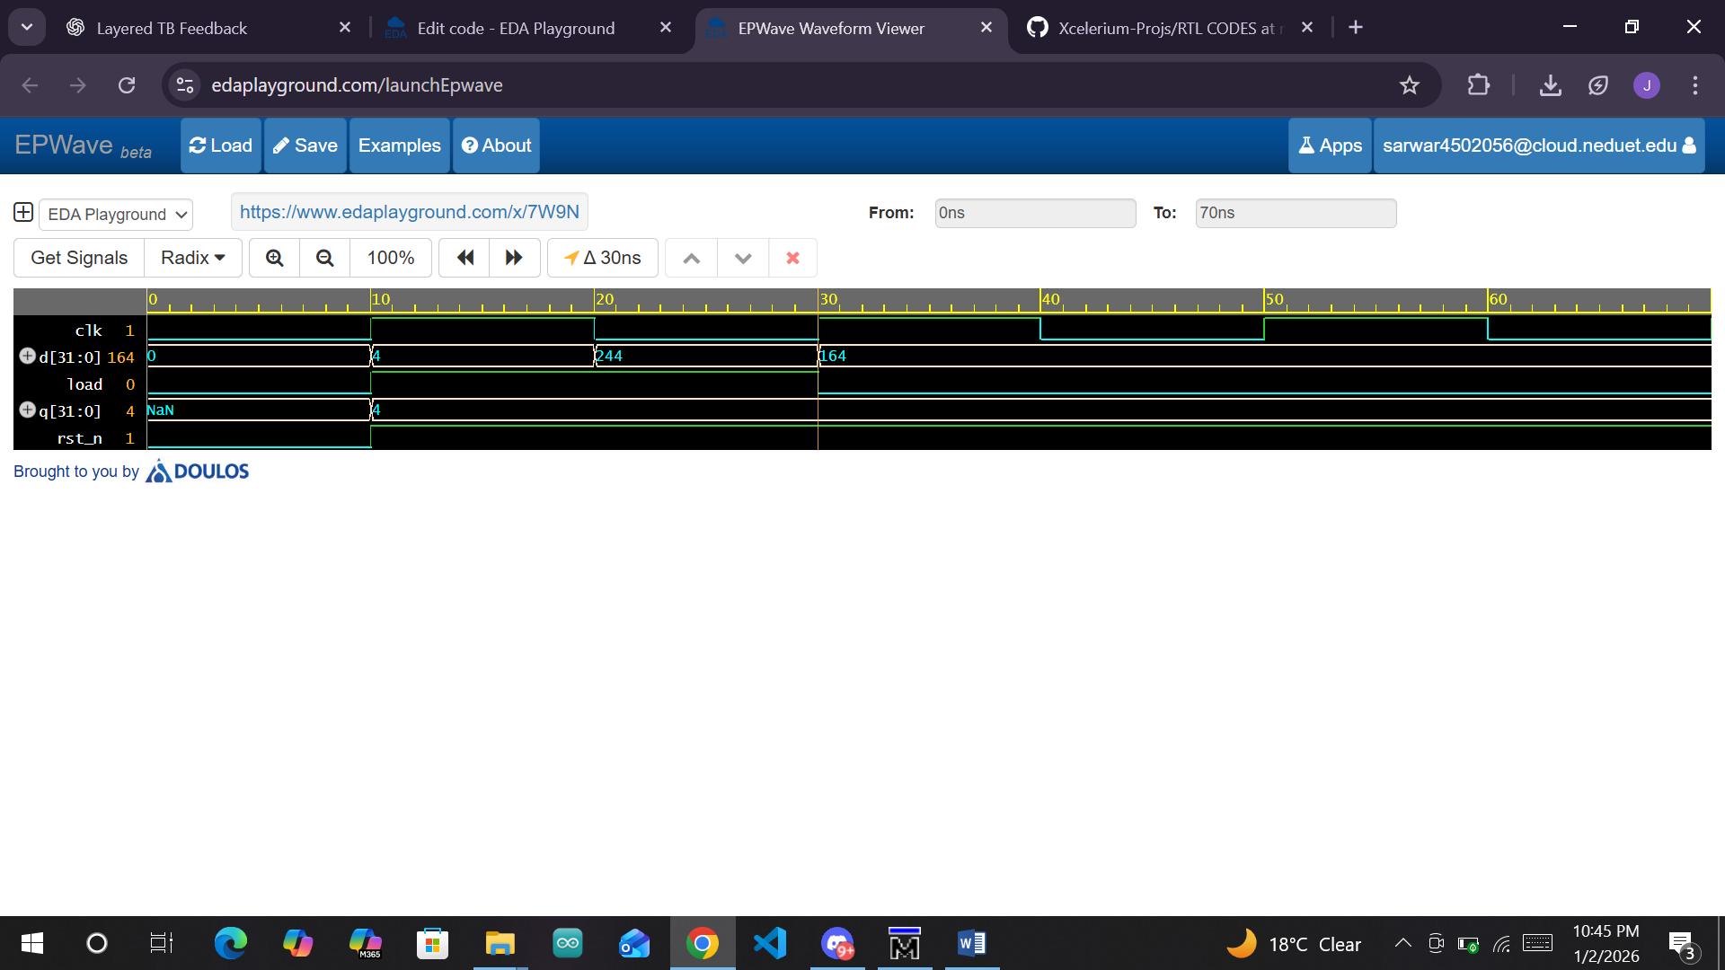

TRANSCRIPT
# run -all
# ** Error: Hold assertion failed at time 10
# Time: 10 ns Started: 10 ns Scope: top_tb File: testbench.sv Line: 55
# ** Error: Reset assertion failed at time 10
# Time: 10 ns Started: 10 ns Scope: top_tb File: testbench.sv Line: 44
# ** Error: Load assertion failed at time 30
# Time: 30 ns Started: 30 ns Scope: top_tb File: testbench.sv Line: 50
# ** Note: $finish : testbench.sv(37)

SYNTHESIS
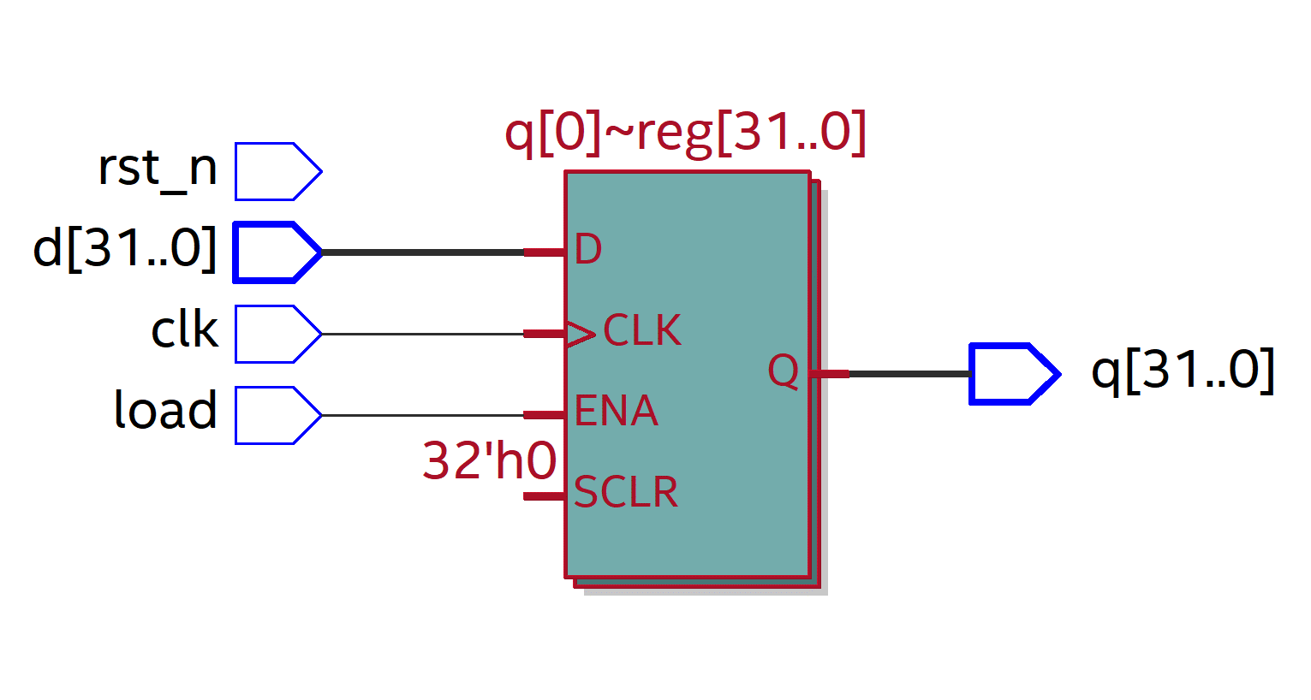

SHIFT_REG:

WAVEFORM
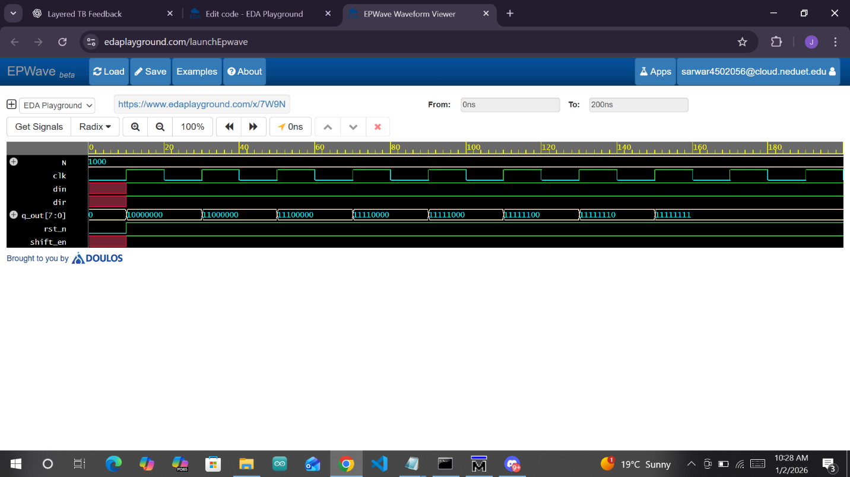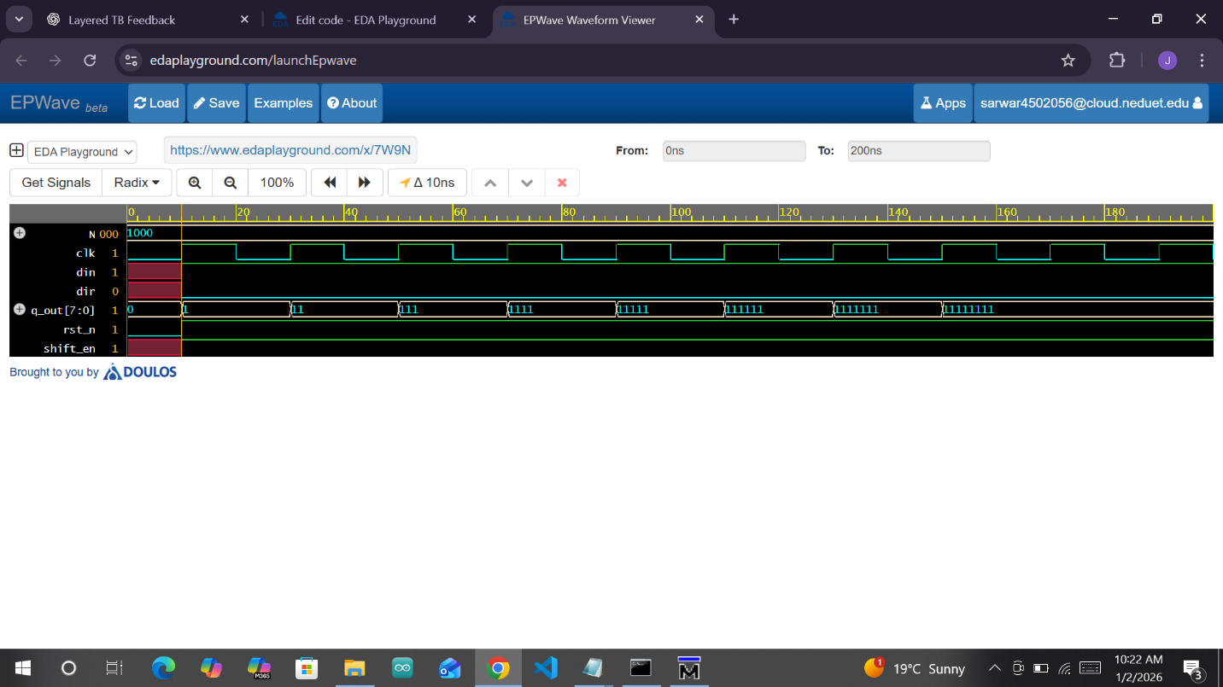

TRANSCRIPT
# din: 1 | dir: 1 | output: 10000000
# MATCH exp=10000000 act=10000000 | PASS
# din: 1 | dir: 1 | output: 11000000
# din: 1 | dir: 1 | output: 11100000
# din: 1 | dir: 1 | output: 11110000
# din: 1 | dir: 1 | output: 11111000
# din: 1 | dir: 1 | output: 11111100
# din: 1 | dir: 1 | output: 11111110
# din: 1 | dir: 1 | output: 11111111
# din: 1 | dir: 1 | output: 11111111
# din: 1 | dir: 0 | output: 00000001
# MATCH exp=00000001 act=00000001 | PASS
# din: 1 | dir: 0 | output: 00000011
# din: 1 | dir: 0 | output: 00000111
# din: 1 | dir: 0 | output: 00001111
# din: 1 | dir: 0 | output: 00011111
# din: 1 | dir: 0 | output: 00111111
# din: 1 | dir: 0 | output: 01111111
# din: 1 | dir: 0 | output: 11111111
# din: 1 | dir: 0 | output: 11111111

SYNTHESIS

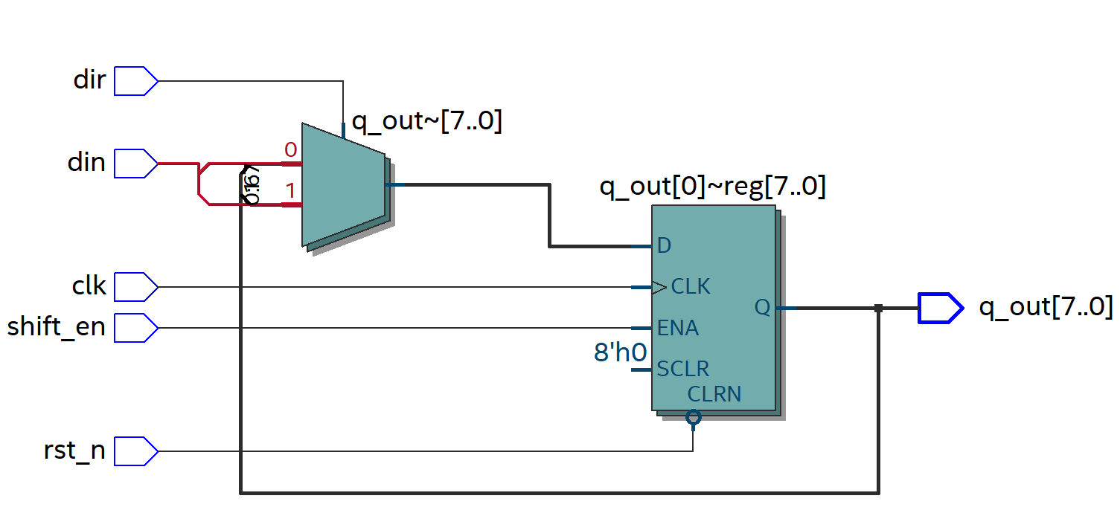

ARRAY_MULT

WAVEFORM
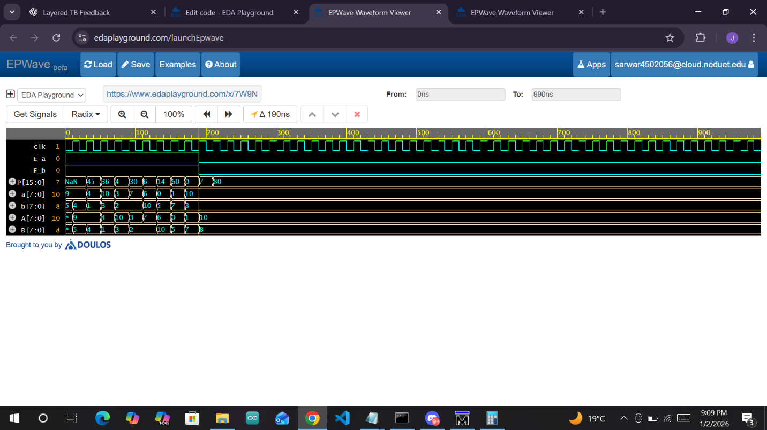

TRANSCRIPT
a: 9 | b: 5 | Prod: x
# MATCH exp= 45 act= 0 | FAIL
a: 9 | b: 5 | Prod: 45
# MATCH exp= 45 act= 45 | PASS
# a: 9 | b: 4 | Prod: 36
# MATCH exp= 36 act= 36 | PASS
# a: 4 | b: 1 | Prod: 4
# MATCH exp= 4 act= 4 | PASS
# a: 10 | b: 3 | Prod: 30
# MATCH exp= 30 act= 30 | PASS
# a: 3 | b: 2 | Prod: 6
# MATCH exp= 6 act= 6 | PASS
# a: 7 | b: 2 | Prod: 14
# MATCH exp= 14 act= 14 | PASS
# a: 6 | b: 10 | Prod: 60
# MATCH exp= 60 act= 60 | PASS
# a: 10 | b: 8 | Prod: 80
# a: 10 | b: 8 | Prod: 80
# a: 10 | b: 8 | Prod: 80

SYNTHESIS
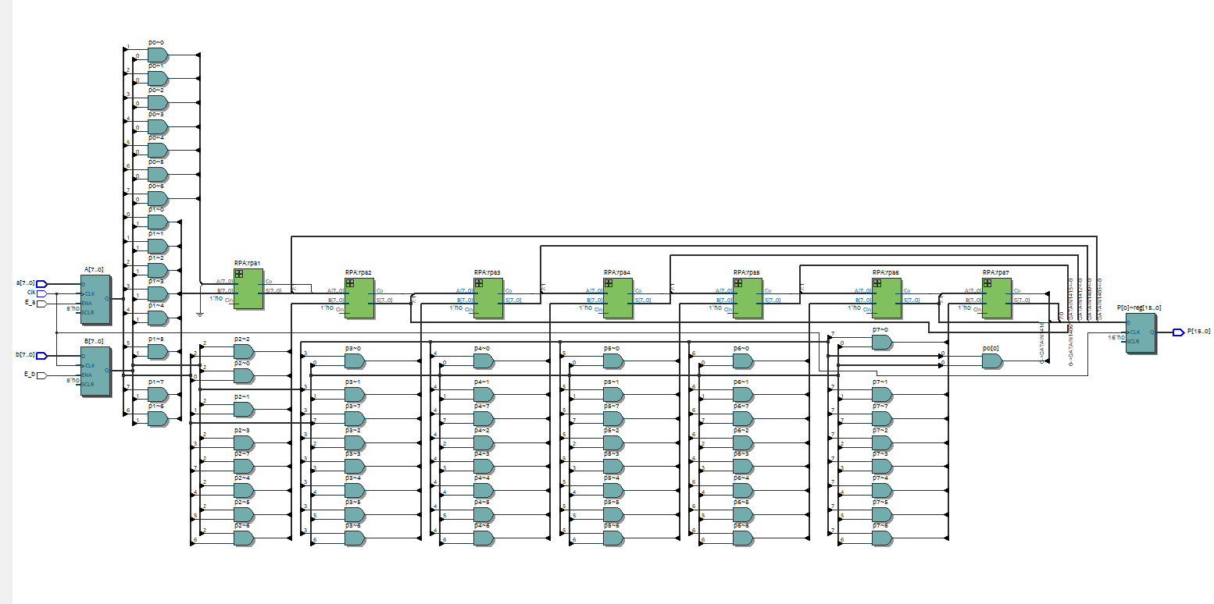

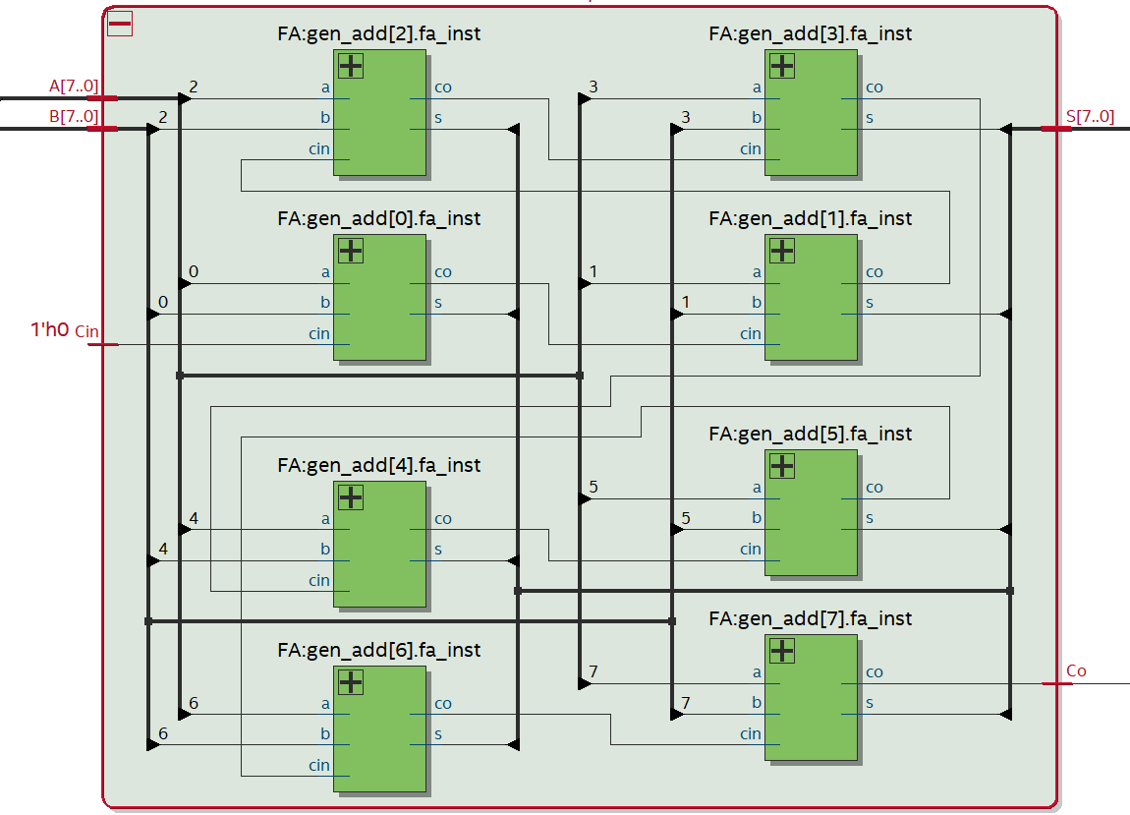

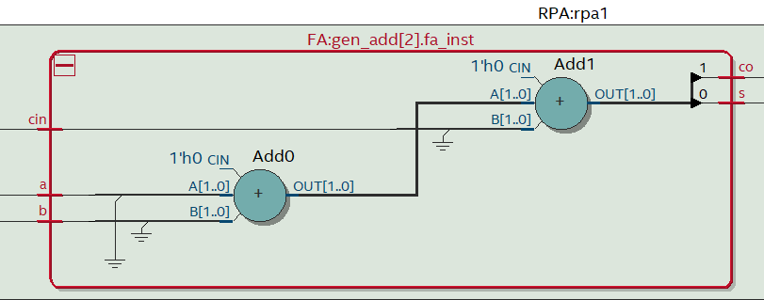

ADDER_TREE_MULT

WAVEFORM
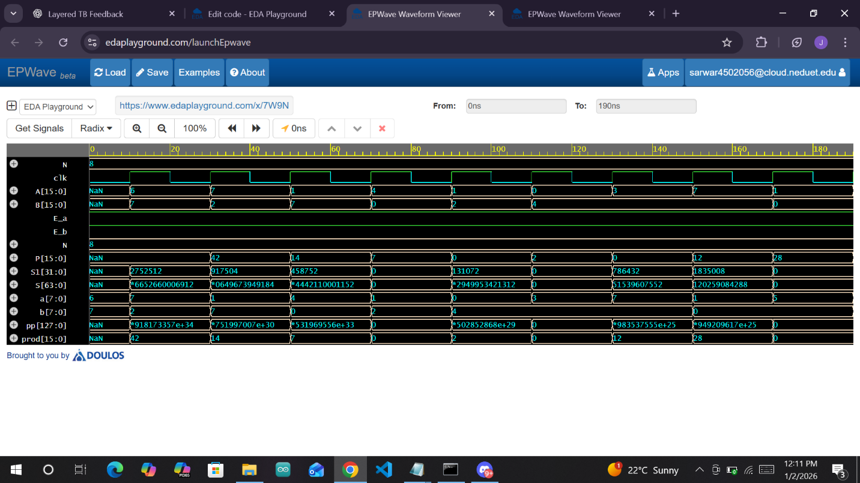

TRANSCRIPT
# a: 7 | b: 2 | Prod: 14
# MATCH exp= 14 act= 14 | PASS
# a: 1 | b: 7 | Prod: 7
# MATCH exp= 7 act= 7 | PASS
# a: 4 | b: 0 | Prod: 0
# MATCH exp= 0 act= 0 | PASS
# a: 1 | b: 2 | Prod: 2
# MATCH exp= 2 act= 2 | PASS
# a: 0 | b: 4 | Prod: 0
# MATCH exp= 0 act= 0 | PASS
# a: 3 | b: 4 | Prod: 12
# MATCH exp= 12 act= 12 | PASS
# a: 7 | b: 4 | Prod: 28
# MATCH exp= 28 act= 28 | PASS
# a: 5 | b: 0 | Prod: 28
# MATCH exp= 0 act= 28 | FAIL

SYNTHESIS
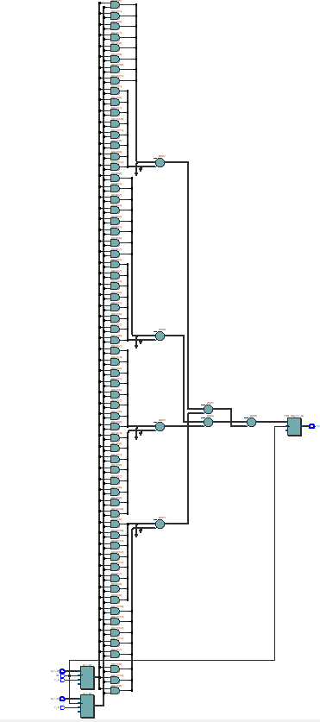

COUNTER

WAVEFORM
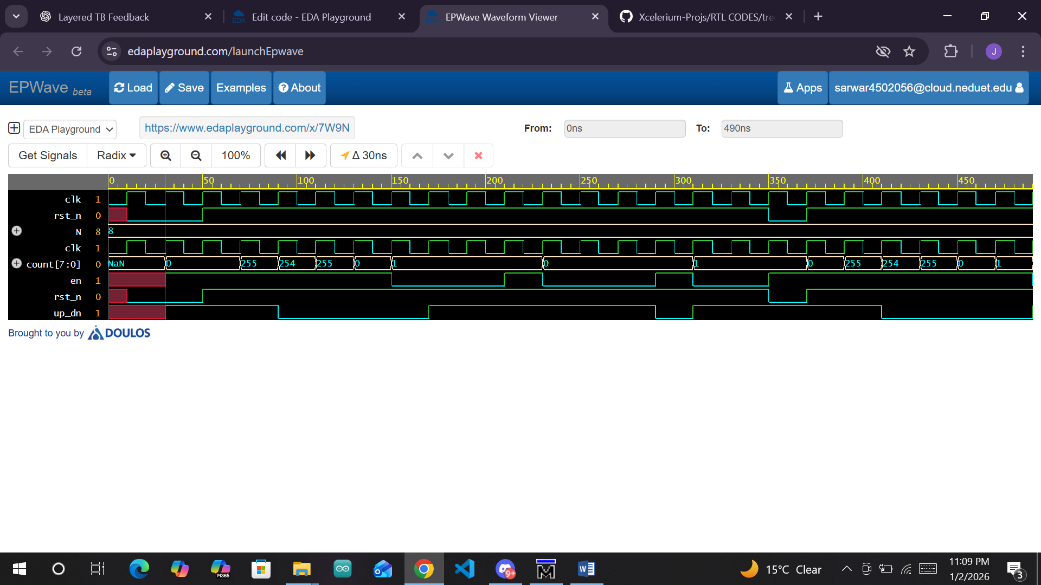

TRANSCRIPT
# run -all
# T= 0 | rst_n = x | en = x | up_dn = x | count = x
# T: 10 | expected_val: x | got_val: x | PASS
# T= 10 | rst_n = 0 | en = x | up_dn = x | count = x
# T: 30 | expected_val: 0 | got_val: x | PASS
# T= 30 | rst_n = 0 | en = 1 | up_dn = 1 | count = 0
# T: 50 | expected_val: 0 | got_val: 0 | PASS
# T= 50 | rst_n = 1 | en = 1 | up_dn = 1 | count = 0
# T: 70 | expected_val: 0 | got_val: 0 | PASS
# T= 70 | rst_n = 1 | en = 1 | up_dn = 1 | count = 255
# T: 90 | expected_val: 255 | got_val: 255 | PASS
# T= 90 | rst_n = 1 | en = 1 | up_dn = 0 | count = 254
# T: 110 | expected_val: 254 | got_val: 254 | PASS
# T= 110 | rst_n = 1 | en = 1 | up_dn = 0 | count = 255
# T: 130 | expected_val: 255 | got_val: 255 | PASS
# T= 130 | rst_n = 1 | en = 1 | up_dn = 0 | count = 0
# T: 150 | expected_val: 0 | got_val: 0 | PASS
# T= 150 | rst_n = 1 | en = 0 | up_dn = 0 | count = 1
# T: 170 | expected_val: 1 | got_val: 1 | PASS
# T= 170 | rst_n = 1 | en = 0 | up_dn = 1 | count = 1
# T: 190 | expected_val: 1 | got_val: 1 | PASS
# T: 210 | expected_val: 1 | got_val: 1 | PASS
# T= 210 | rst_n = 1 | en = 1 | up_dn = 1 | count = 1
# T: 230 | expected_val: 1 | got_val: 1 | PASS
# T= 230 | rst_n = 1 | en = 0 | up_dn = 1 | count = 0
# T: 250 | expected_val: 0 | got_val: 0 | PASS
# T: 270 | expected_val: 0 | got_val: 0 | PASS
# T: 290 | expected_val: 0 | got_val: 0 | PASS
# T= 290 | rst_n = 1 | en = 1 | up_dn = 0 | count = 0
# T: 310 | expected_val: 0 | got_val: 0 | PASS
# T= 310 | rst_n = 1 | en = 0 | up_dn = 1 | count = 1
# T: 330 | expected_val: 1 | got_val: 1 | PASS
# T: 350 | expected_val: 1 | got_val: 1 | PASS
# T= 350 | rst_n = 0 | en = 1 | up_dn = 1 | count = 1
# T: 370 | expected_val: 0 | got_val: 1 | FAIL
# T= 370 | rst_n = 1 | en = 1 | up_dn = 1 | count = 0
# T: 390 | expected_val: 0 | got_val: 0 | PASS
# T= 390 | rst_n = 1 | en = 1 | up_dn = 1 | count = 255
# T: 410 | expected_val: 255 | got_val: 255 | PASS
# T= 410 | rst_n = 1 | en = 1 | up_dn = 0 | count = 254
# T: 430 | expected_val: 254 | got_val: 254 | PASS
# T= 430 | rst_n = 1 | en = 1 | up_dn = 0 | count = 255
# T: 450 | expected_val: 255 | got_val: 255 | PASS
# T= 450 | rst_n = 1 | en = 1 | up_dn = 0 | count = 0
# T: 470 | expected_val: 0 | got_val: 0 | PASS
# T= 470 | rst_n = 1 | en = 1 | up_dn = 0 | count = 1
# T: 490 | expected_val: 1 | got_val: 1 | PASS
# T= 490 | rst_n = 1 | en = 0 | up_dn = 1 | count = 2
# ** Note: $finish : testbench.sv(16)

SYNTHESIS
